AMP Database Tool

User Manual  
Bruce Taylor, Rocket Science Consulting

## Starting and Stopping

The AMP Database tool is a Java application, and can be started in one of two ways:

1. Double-clicking on the “AMPDBTool.jar” icon 
2. From the command line: java –jar AMPDBTool.jar

The AMP Database tool can be stopped by closing (not minimizing) its window, or using the File->Quit menu item.

## General Operation

The AMP Database Tool’s window is shown below. It comprises three sections:

1. The File menu controls selection of AMP projects to be imported into the database
2. The Database menu controls the selection, creation, and population of databases with AMP data.
3. The Progress Window that shows progress of population operations and any errors that occur during those operations.



## Managing Projects

An AMP DB “project” is a root directory of an AMP output directory tree. All Metadata files accessible from the root directory will be included in schema generation and database population. The project is controlled from the “File” menu as shown:

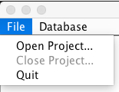

The “Open Project” menu item opens the following dialog that allows the user to select the project root either by entering its path directly or be using the standard file chooser widget. The “Close Project” menu item removes the current project path from consideration.

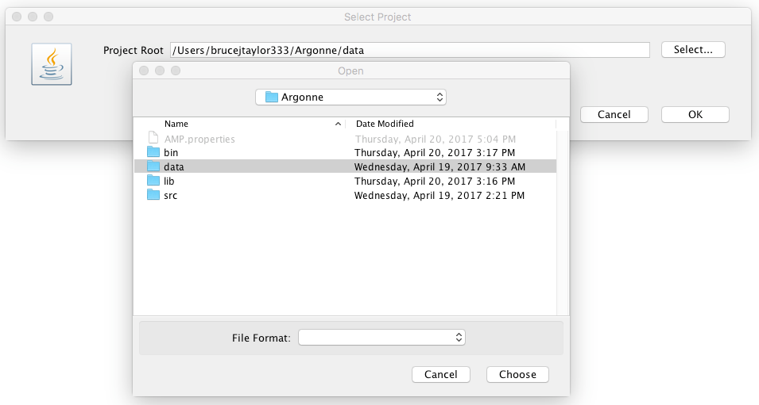

When a project is opened, the AMP Database tool immediately reads and parses all metadata files (those whose file extension is “.meta”) and reports errors on the progress window as shown below.

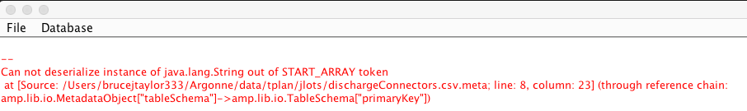

## Managing Databases

The AMP Database Tool supports the basic operations on databases, as shown in the menu illustrated below:

1. Opening a database  
   The user must select an available database and supply a user name and password.
2. Creating a database  
   The user must supply a database name, a user name, and an appropriate password.
3. Dropping a database  
   The selected database is deleted and removed from the available database list
4. Build Database Schema  
   The tool will clear all tables from the specified database and create new tables and indices as determined by the metadata files in the project.
5. Populate Database  
   The tool will empty all tables in the database and reload their contents from the CSV files in the project, as directed by the metadata files.

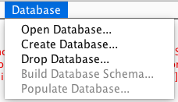

## Building Database Schemas

When the user selects the “Build Database Schema” menu item, the AMP Database Tool uses each metadata file to create a new table in the database. The following illustrations show the “aircraftTypes.csv.meta” file and the table definition derived from it.

{

    "id": "/fedResults/aircraftType.csv.meta",

    "title": "AircraftType",

    "scenario": "metadata-scenario",

    "classname": "ampfed.domain.entity.AircraftType",

    "ampversion": "14.13.0 alpha1",

    "tableSchema": {

        "columns": [

            {

                "name": "Model",

                "titles": "Model",

                "description": "Enumerated type enumerating the models supported by this federation",

                "datatype": "string"

            },

            {

                "name": "FedTime",

                "titles": "FedTime",

                "description": "The federation time of this interaction",

                "datatype": "float"

            },

            {

                "name": "BlockSpeed500",

                "titles": "BlockSpeed500",

                "description": "500 nm block speed in knots.",

                "datatype": "float"

        ],

        "primaryKey": "Model",

        "foreignKeys": [

            {

                "columnReference": "Model",

                "reference": {

                    "schemaReference": "/fedResults/modelTypes.csv.meta",

                    "columnReference": "ModelType"

                }

            },

            {

                "columnReference": "Size",

                "reference": {

                    "schemaReference": "/fedResults/aircraftTypeSize.csv.meta",

                    "columnReference": "AircraftTypeSize"

                }

            }

        ]

    }

}

Some Columns Removed for Clarity

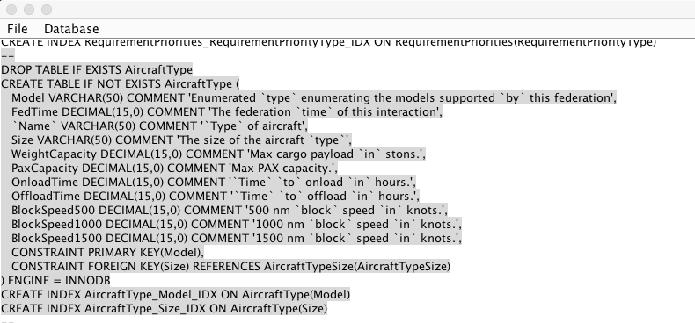

Table definitions have the following features:

1. Table name taken from the metadata “title” field
2. Columns taken from the metadata “columns” array
3. Column datatypes translated from metadata “datatype” field
4. Column comments taken from metadata “description” field
5. Primary key constraint taken from metadata “primaryKey” field
6. Foreign key constraints taken from metadata “foreignKey” array
7. One index per primary and secondary key.
8. MySQL keywords are escaped everywhere by back-tick (`) characters

Errors in table construction are reported in the progress window in red characters:

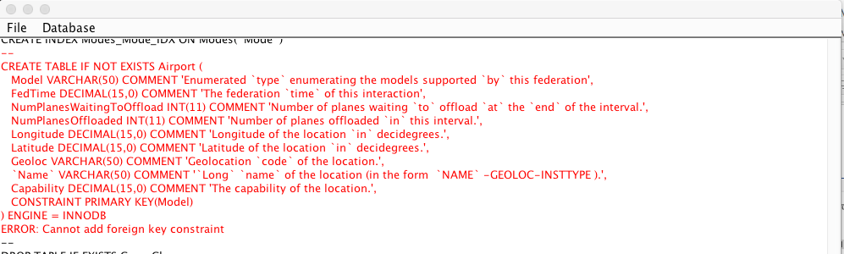

## Populating Databases

When the user selects the “Populate Database” menu item, the AMP Database Tool will attempt to populate all the tables created in schema generation. For each metadata file in the project, it attempts to locate its corresponding data (CSV) file by removing the “.meta” suffix from the metadata file name. It uses the database’s bulk load command to copy data from the CSV file into the table according to the following rules:

1. Referential integrity checking is suspended during data population
2. Columns in the CSV file must be in the same order as they are defined in the metadata file.
3. The CSV file is assumed to have column name definitions in the first row, but CSV column names are disregarded.
4. CSV columns are delimited by commas (,) and optionally enclosed by quotes, if the contents contain a comma.
5. Empty CSV column values translate to a null database value.
6. CSV values are taken as strings, and mapped to column datatypes according to the database’s conversion rules.

The screen capture below illustrates data population, including report of an error shown in red.

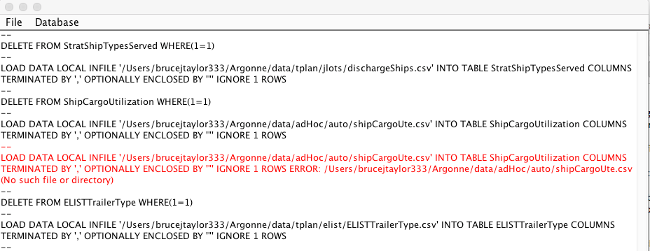

## Properties

For user convenience, the AMP Database Tool records the following information in the file “AMP.properties” in the user’s home directory.

1. Most recent project opened, as path to the project’s root directory
2. Most recent database opened, including user name and password.

## This information is used to prepopulate project and database selection dialogs. The AMP.properties file can safely be deleted at any time.

#

#Fri Apr 21 10:59:17 CDT 2017

db.password=root

db.user=root

db.name=Amp

proj.root=/Users/brucejtaylor333/Argonne/data